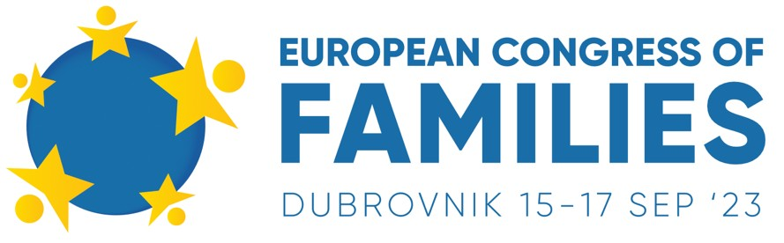

Dubrovnik President Valamar Collection Hotel, Conference Hall OLIPA Iva Dulčića Street 142, Dubrovnik

Friday, September 15

Introductory remarks – Ladislav Ilčić MEP (host)
Live debate with
Eugenia Maria Roccella, Italian Minister for Family, Natality and Equal Opportunities

1st panel - FAMILY & CULTURE: Bringing the universal values back to the EU mainstream

Moderator: Adela Mirza, Alternativa Dreapta President (Romania) Nino Raspudić MP – Croatian Parliament
Sanja Nikčević – University professor and theatre critic Keith Mason – „Sound of Freedom“ associate producer
David Ibáñez - Political Network for Values, Family and Civil Society Dan Đaković – University of Zagreb professor

2nd panel - FAMILY & THE ECONOMY: Can they grow together?

Moderator: Mate Mijić
Vesna Vučemilović MP – Croatian Parliament, Family Committee Chairwoman Ranil Jayawardena MP – UK House of Commons
Andrej Grubišić - Economics expert and private consultant Tilman Ruesch – Serial investor
Ian Wilders – Businessman & author on leadership

3rd panel - FAMILY & DEMOGRAPHY: Battling low birth rates in the EU with pro-family policies

Moderator: Ivan Malbašić – ELFAC Board Member Margarita de la Pisa MEP – European Parliament (Spain) Elżbieta Rafalska MEP – European Parliament (Poland) Nicola Speranza – FAFCE Secretary General
Allan Carlson – Historian and author, IOF
Elīna Treija – Union of Latvian Large Families

4th panel - FAMILY & EDUCATION: Putting parents in the center of the system that pushes them aside

Moderator: Ladislav Ilčić MEP
Jadwiga Wiśniewska MEP – European Parliament (Poland) Hermann Tertsch MEP – European Parliament (Spain) Miriam Cates MP – UK House of Commons
Mark Randall – National Catholic Prayer Breakfast Chairman (USA)

5h panel - FAMILY & BUSINESS: 'Made by a Family' as a driving principle of the EU and Western economy

Moderator: Vesna Vučemilović MP
Rob Roos MEP – ECR Group Vice Chairman (the Netherlands) Ján Oravec MP – National Council of the Slovak Republic (Sas) Michael Tapp – Businessman, Tapp Holdings
Jacob Uhlenkott – Businessman, Soliloquy Strategic Chris Faddis - Solidarity Healthshare CEO

Special guest: msgr. Roko Glasnović, Bishop of Dubrovnik

Saturday, September 16

Brian Brown, International Organization for the Family Chairman (USA) – Keynote speech

6th panel - FAMILY & SECURITY: Avoiding social chaos with safe family-friendly communities in the EU

Moderator: Marin Periš
Nikola Grmoja MP – Croatian Parliament
Slaven Raguž MP – FBiH Parliament (Bosnia & Herzegovina) Victor Guido González Coello de Portugal – VOX party (Spain) Guillaume de Thieulloy – Les 4 Vérités Hebdo (France)

Nicola Procaccini MEP – ECR Group in the European Parliament Co-chairman (Italy) – Keynote speech

7th panel - FAMILY & TECHNOLOGY: Great new possibilities and even greater dangers in the digital era

Moderator: Krisztina Karvovszki (MCC Brussels) Cinzia Pellegrino – Italian Senate (Fratelli d'Italia) Diego von Stauffenberg – Expert, Rivada Networks
David G. Lejeune – Businessman & technologist, ALTERNcloud CEO John Sutton – Digital currency expert, Sutton Selects CEO

Drew Ryun – 'Power of the vote: Family in the political arena' – Short presentation

Sunday, September 17

Workshop: Strategic approach to cultural change and promotion of traditional family in the EU
Attending mass together at Dubrovnik city centre (St Blaise's Cathedral)

